[Mariska Hargitay Snaps Selfie With Christopher Meloni: 'It's On'](https://www.etonline.com/mariska-hargitay-snaps-selfie-with-christopher-meloni-its-on-149932?amp&__twitter_impression=true&s=09)

**Paige Gawley‍**

9:57 AM PDT, July 20, 2020

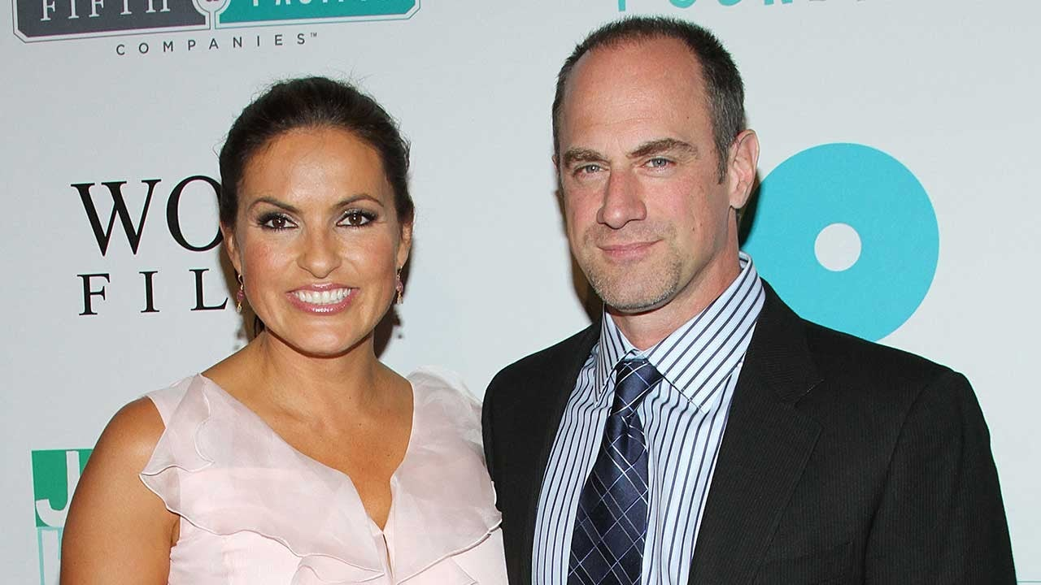

Rob Kim/Getty Images

Olivia Benson and Elliot Stabler are together again! [**Mariska Hargitay**](https://www.etonline.com/people/mariska-hargitay) and [**Christopher Meloni**](https://www.etonline.com/people/christopher-meloni) both took to Instagram on Sunday to share sweet selfies they took during a recent reunion.

The actors co-starred on *Law and Order: Special Victims Unit* for 12 seasons, from 1999 to 2011.

The duo is all smiles in the sweet pics, with Meloni's arm wrapped around Hargitay's shoulders as they stand close together.

"It's on," Hargitay wrote alongside one pic, adding that their reunion was "easy like Sunday morning" in [**a second post**](https://www.instagram.com/p/CC2epMgnqpe/).

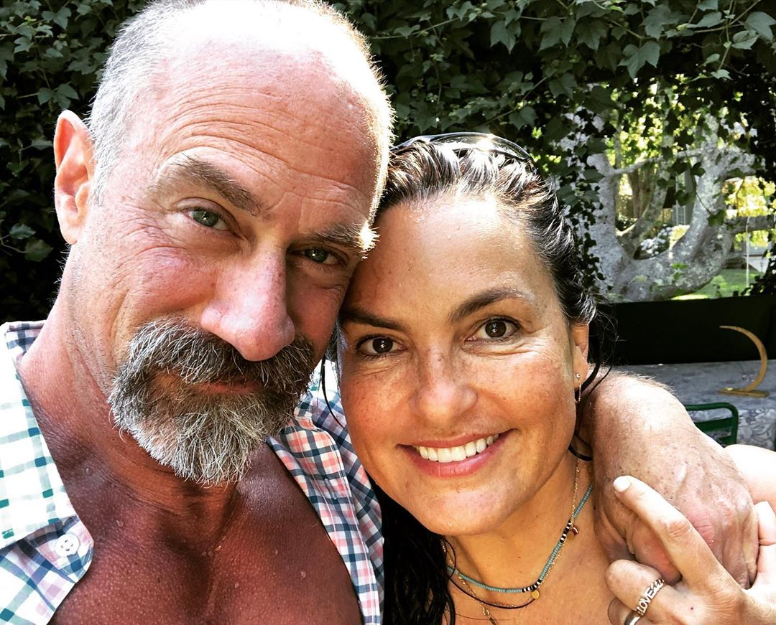

Meloni shared a similar pic on his Instagram page, writing, "Ladybug on my face n a lady on my arm #hanginWithBenson"

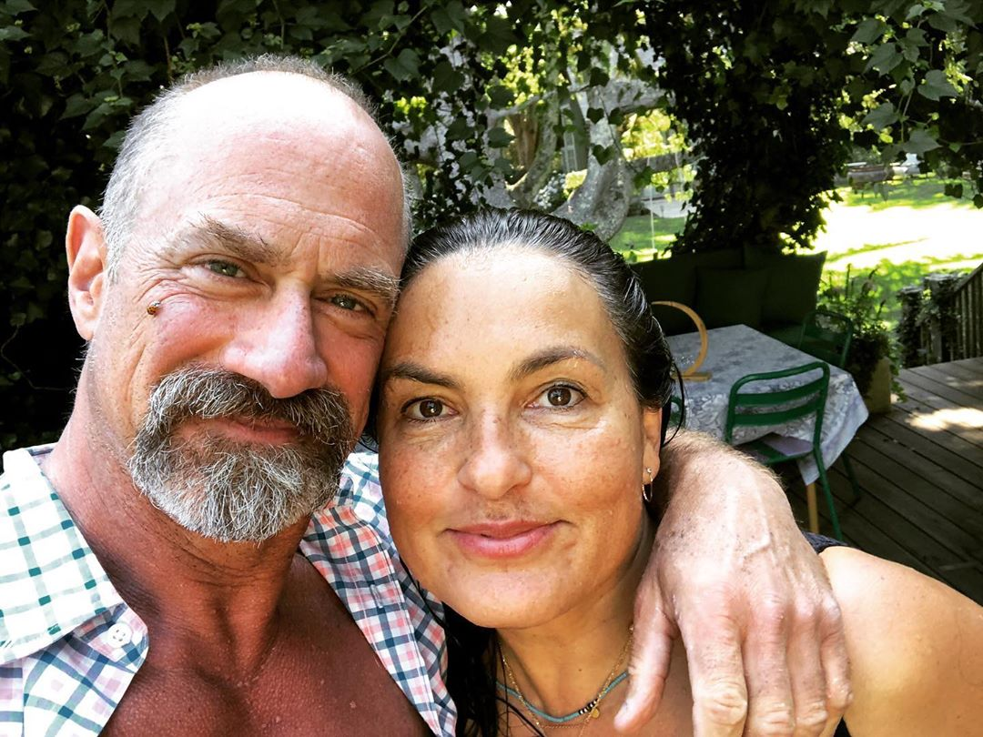

Meloni left *SVU* back in 2011, but [**will soon reprise his role**](https://www.etonline.com/christopher-meloni-reprising-svu-character-det-elliot-stabler-for-new-nbc-series-143986) in a spinoff series, which will follow the former detective as he returns to the force to head up the Organized Crime Division of the NYPD.

In a May episode of [***the Law & Order: SVU Podcast***](https://www.nbc.com/law-and-order-special-victims-unit/exclusives/svu-podcast/video/4036795), showrunner [**Warren Leight revealed**](https://www.etonline.com/christopher-meloni-returning-to-svu-in-season-22-premiere-ahead-of-new-series-145822) that Meloni will appear on *SVU* before the start of his series.

"It’s pretty clear that Elliot will be in the *SVU* season opener," Leight said. "I think that much I know. Whether we get to see his family as well remains to be seen."

"It's not just about the *SVU* season opener, it's how do we help launch the new series and how much crossover will there be between Elliot and Olivia as the season goes on," Leight added.

Watch the video below for more on *SVU*.